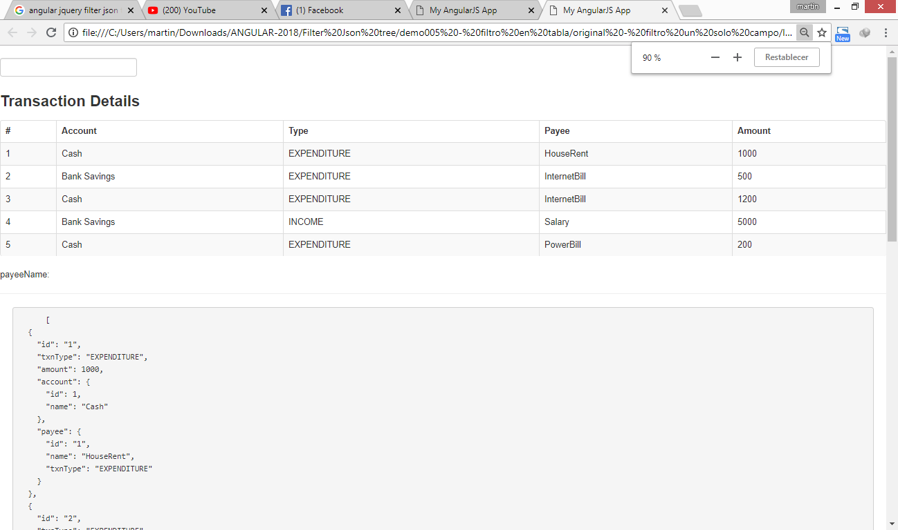

Fuente:

<https://gist.github.com/sivaprasadreddy/fbee047803d14631fafd>

<https://www.javacodegeeks.com/2014/09/angularjs-different-ways-of-using-array-filters.html>

angular.min.js (AngularJS v1.0.7, preferencia v.1.5.6)

jquery-1.9.1.js (jQuery JavaScript Library v1.9.1)

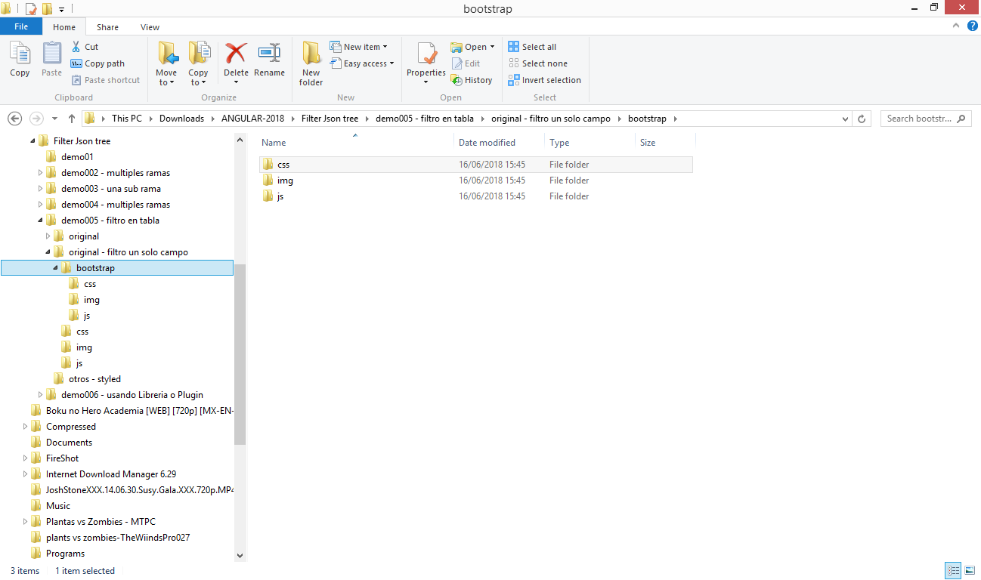

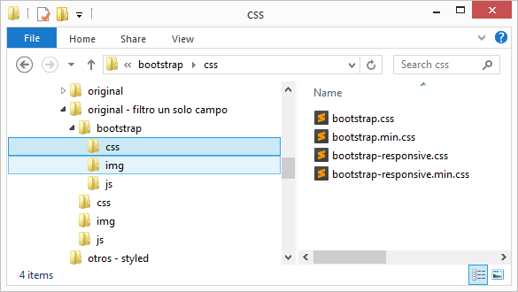

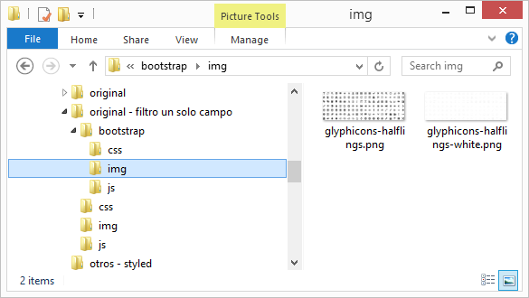

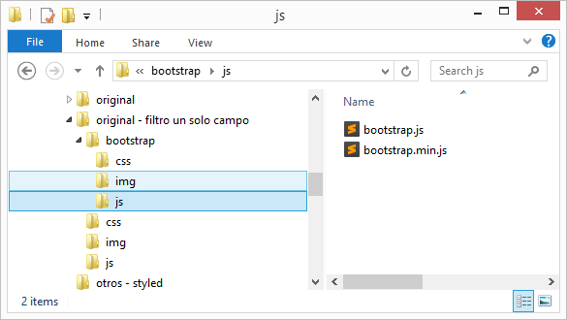

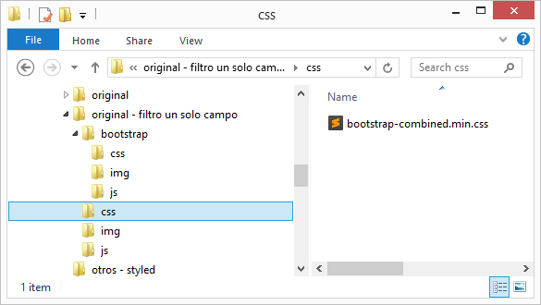

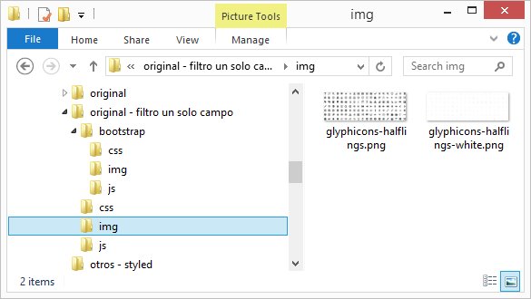

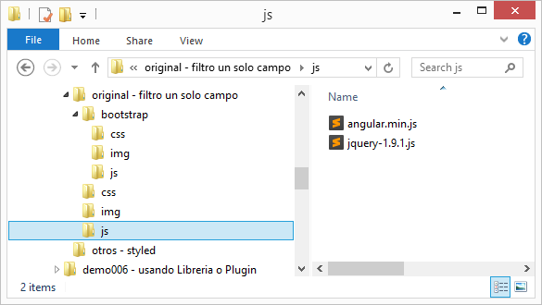

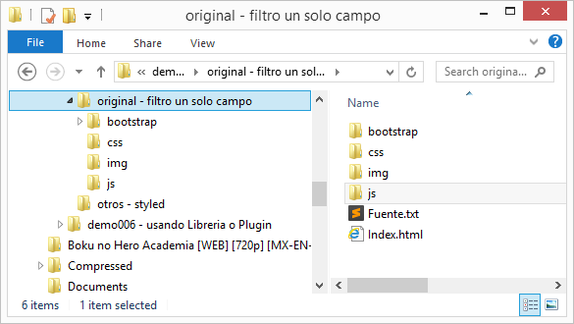

Index.html

|  |
| --- |
| <!DOCTYPE html>  <html ng-app="myApp">  <head>  <meta charset="utf-8">  <meta http-equiv="X-UA-Compatible" content="IE=edge">  <title>My AngularJS App</title>  <meta name="description" content="">  <meta name="viewport" content="width=device-width, initial-scale=1">  <link href="bootstrap/css/bootstrap.min.css" rel="stylesheet" type="text/css" />  <script src="./js/angular.min.js"></script>  <script src="./js/jquery-1.9.1.js"></script>  <script src="bootstrap/js/bootstrap.min.js"></script>  <!DOCTYPE html>  <html ng-app="myApp">  <script>  var myApp = angular.module('myApp', []);  myApp.controller('SampleController', function ($scope) {  $scope.accounts = [  { id: 1, name: 'Cash' },  { id: 2, name: 'Bank Savings' }  ];  $scope.payees = [  { id: '1', name: 'HouseRent', txnType: 'EXPENDITURE' },  { id: '2', name: 'InternetBill', txnType: 'EXPENDITURE' },  { id: '3', name: 'PowerBill', txnType: 'EXPENDITURE' },  { id: '4', name: 'Salary', txnType: 'INCOME' }  ];  $scope.transactions = [  { id: '1', txnType: 'EXPENDITURE', amount: 1000, account: $scope.accounts[0], payee: $scope.payees[0] },  { id: '2', txnType: 'EXPENDITURE', amount: 500, account: $scope.accounts[1], payee: $scope.payees[1] },  { id: '3', txnType: 'EXPENDITURE', amount: 1200, account: $scope.accounts[0], payee: $scope.payees[1] },  { id: '4', txnType: 'INCOME', amount: 5000, account: $scope.accounts[1], payee: $scope.payees[3] },  { id: '5', txnType: 'EXPENDITURE', amount: 200, account: $scope.accounts[0], payee: $scope.payees[2] }  ];  });  </script>  </head>  <body ng-controller="SampleController" ng-init="payeeName=''">  <br />  <input type="text" ng-model="payeeName">  <br />  <div class="col-md-8 col-md-offset-2">  <h3>Transaction Details</h3>  <table class="table table-striped table-bordered">  <thead>  <tr>  <th>#</th>  <th>Account</th>  <th>Type</th>  <th>Payee</th>  <th>Amount</th>  </tr>  </thead>  <tbody>  <tr ng-repeat="txn in transactions| filter: {payee.name : payeeName}">  <!-- <tr ng-repeat="txn in transactions"> -->  <td>**{{**$index + 1**}}**</td>  <td>**{{**txn.account.name**}}**</td>  <td>**{{**txn.txnType**}}**</td>  <td>**{{**txn.payee.name**}}**</td>  <td>**{{**txn.amount**}}**</td>  </tr>  </tbody>  </table>  </div>  payeeName:**{{**payeeName**}}**  <hr />  <div class="container-fluid">  <pre>  **{{**transactions | json**}}**  </pre>  </div>  <hr />  </body>  </html> |